Polar radius
# Source: AI Source: Provided by: [Data Path: Persons Table -> ID Column: 1, Name_En Column: Motasem Essam] -> From: [ChatGPT] on [7/25/2026]
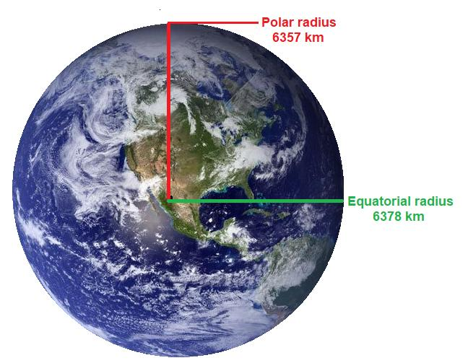
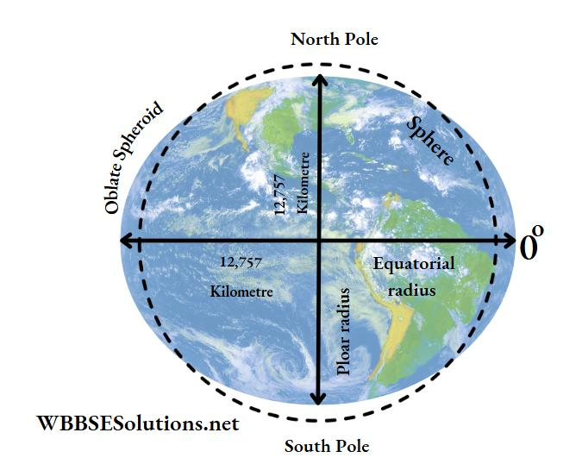
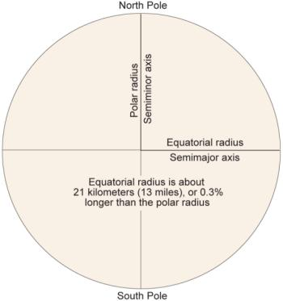

Definition
# Source: AI Source: Provided by: [Data Path: Persons Table -> ID Column: 1, Name_En Column: Motasem Essam] -> From: [ChatGPT] on [7/25/2026]
The polar radius is the distance from the center of a sphere or sphere-like body to either of its poles, measured along its polar axis.
For a perfect sphere, the polar radius is equal to the ordinary radius because every point on the surface is equally distant from the center.
For an oblate spheroid, such as Earth, the polar radius is shorter than the equatorial radius because the body is slightly flattened at the poles.

Simple Definition
# Source: AI Source: Provided by: [Data Path: Persons Table -> ID Column: 1, Name_En Column: Motasem Essam] -> From: [ChatGPT] on [7/25/2026]
The polar radius is the distance from the center of a spherical or spheroid-shaped body to its North Pole or South Pole.
- Starting point: The center of the body.
- Ending point: Either pole.
- Direction: Along the polar axis.
- Length: Equal to the ordinary radius for a perfect sphere; potentially different for a spheroid.
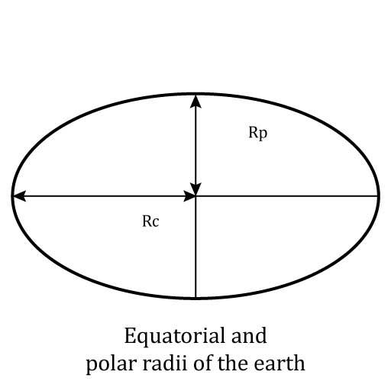

Geometric Representation
# Source: AI Source: Provided by: [Data Path: Persons Table -> ID Column: 1, Name_En Column: Motasem Essam] -> From: [ChatGPT] on [7/25/2026]
Let $O$ be the center of a sphere-like body, $N$ its North Pole, and $S$ its South Pole.
The polar radius is represented by either segment:
$$\overline{ON} \text{or} \overline{OS}$$
For a body symmetric about its polar axis:
$$ON=OS=R_{p}$$
where $R_{p}$ denotes the polar radius.
Polar radius in different shapes
- Perfect sphere: The polar radius equals every other radius.
- Oblate spheroid: The polar radius is shorter than the equatorial radius.
- Prolate spheroid: The polar radius is longer than the equatorial radius.

Types and Related Measurements
# Source: AI Source: Provided by: [Data Path: Persons Table -> ID Column: 1, Name_En Column: Motasem Essam] -> From: [ChatGPT] on [7/25/2026]
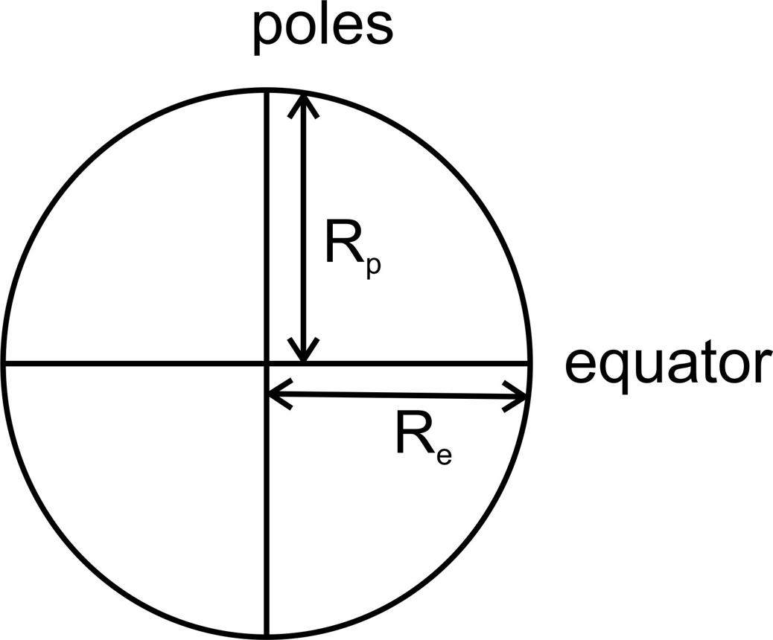

Polar Radius of a Sphere
# Source: AI Source: Provided by: [Data Path: Persons Table -> ID Column: 1, Name_En Column: Motasem Essam] -> From: [ChatGPT] on [7/25/2026]
For a perfect sphere, all radii are equal.
$$R_{p}=R$$
The polar radius has the same length as the equatorial radius.

Polar Radius of an Oblate Spheroid
# Source: AI Source: Provided by: [Data Path: Persons Table -> ID Column: 1, Name_En Column: Motasem Essam] -> From: [ChatGPT] on [7/25/2026]
An oblate spheroid is flattened at its poles.
$$R_{p}<R_{e}$$
Earth is approximately an oblate spheroid.
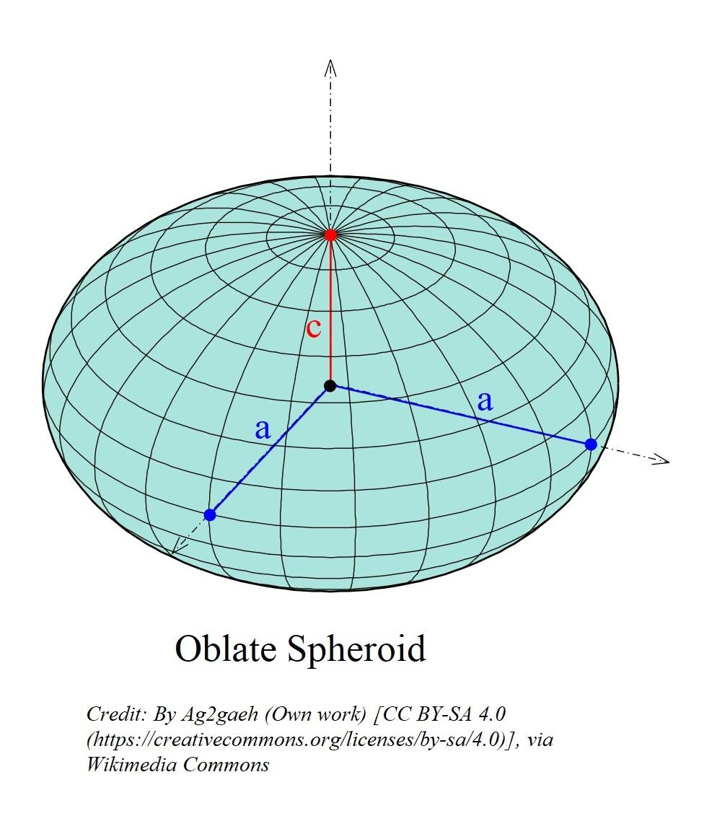

Polar Radius of a Prolate Spheroid
# Source: AI Source: Provided by: [Data Path: Persons Table -> ID Column: 1, Name_En Column: Motasem Essam] -> From: [ChatGPT] on [7/25/2026]
A prolate spheroid is elongated along its polar axis.
$$R_{p}>R_{e}$$
Its polar radius is longer than its equatorial radius.
Here, $R_{p}$ is the polar radius and $R_{e}$ is the equatorial radius.

Key Characteristics
# Source: AI Source: Provided by: [Data Path: Persons Table -> ID Column: 1, Name_En Column: Motasem Essam] -> From: [ChatGPT] on [7/25/2026]
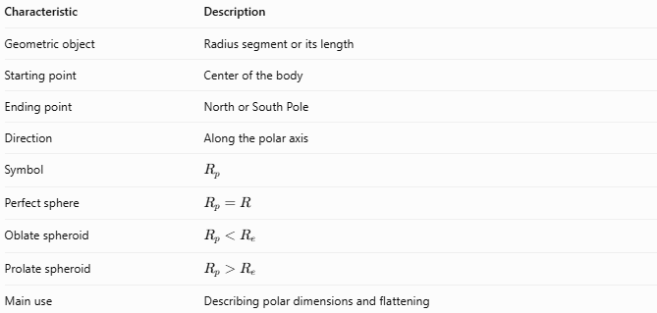
Characteristic | Description
Geometric object | Radius segment or its length
Starting point | Center of the body
Ending point | North or South Pole
Direction | Along the polar axis
Symbol | $$R_{p}$$
Perfect sphere | $$R_{p}=R$$
Oblate spheroid | $$R_{p}<R_{e}$$
Prolate spheroid | $$R_{p}>R_{e}$$
Main use | Describing polar dimensions and flattening

Mathematical Formulas

Polar Radius of a Perfect Sphere
# Source: AI Source: Provided by: [Data Path: Persons Table -> ID Column: 1, Name_En Column: Motasem Essam] -> From: [ChatGPT] on [7/25/2026]
$$\boxed{R_{p}=R}$$
where $R$ is the sphere's ordinary radius.

Polar Diameter
# Source: AI Source: Provided by: [Data Path: Persons Table -> ID Column: 1, Name_En Column: Motasem Essam] -> From: [ChatGPT] on [7/25/2026]
For a symmetric sphere-like body, the polar diameter is twice the polar radius:
$$\boxed{D_{p}=2R_{p}}$$
Therefore:
$$\boxed{R_{p}=\frac{D_{p}}{2}}$$

Polar Flattening
# Source: AI Source: Provided by: [Data Path: Persons Table -> ID Column: 1, Name_En Column: Motasem Essam] -> From: [ChatGPT] on [7/25/2026]
For an oblate spheroid, flattening can be expressed as:
$$\boxed{f=\frac{R_{e}-R_{p}}{R_{e}}}$$
where:
- $R_{e}$ = equatorial radius.
- $R_{p}$ = polar radius.
- $f$ = flattening factor.
A perfect sphere has $f=0$.

Equation of an Axis-Aligned Spheroid
# Source: AI Source: Provided by: [Data Path: Persons Table -> ID Column: 1, Name_En Column: Motasem Essam] -> From: [ChatGPT] on [7/25/2026]
For a spheroid centered at the origin with its polar axis along the $z$-axis:
$$\boxed{\frac{x^{2}+y^{2}}{R_{e}^{2}}+\frac{z^{2}}{R_{p}^{2}}=1}$$
This equation describes an oblate spheroid when $R_{p}<R_{e}$, a prolate spheroid when $R_{p}>R_{e}$, and a sphere when $R_{p}=R_{e}$.

Worked Examples
# Source: AI Source: Provided by: [Data Path: Persons Table -> ID Column: 1, Name_En Column: Motasem Essam] -> From: [ChatGPT] on [7/25/2026]
Example 1 — Polar Radius of a Sphere
A perfect sphere has an ordinary radius of $8\text{ cm}$. Find its polar radius.
Solution:
$$R_{p}=R$$
$$\boxed{R_{p}=8\text{ cm}}$$
Example 2 — Finding Polar Radius from Polar Diameter
A spheroid has a polar diameter of $12\text{ m}$. Find its polar radius.
Solution:
$$R_{p}=\frac{D_{p}}{2}$$
$$R_{p}=\frac{12}{2}$$
$$\boxed{R_{p}=6\text{ m}}$$
Example 3 — Comparing Polar and Equatorial Radii
A spheroid has an equatorial radius of $10\text{ m}$ and a polar radius of $9.8\text{ m}$. Determine its shape and flattening.
Solution:
Since
$$9.8<10$$
the spheroid is oblate.
Its flattening is:
$$f=\frac{10-9.8}{10}=\frac{0.2}{10}$$
$$\boxed{f=0.02=2\%}$$

Polar Radius vs. Equatorial Radius
# Source: AI Source: Provided by: [Data Path: Persons Table -> ID Column: 1, Name_En Column: Motasem Essam] -> From: [ChatGPT] on [7/25/2026]
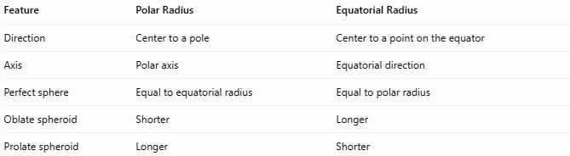
Feature | Polar Radius | Equatorial Radius
Direction | Center to a pole | Center to a point on the equator
Axis | Polar axis | Equatorial direction
Perfect sphere | Equal to equatorial radius | Equal to polar radius
Oblate spheroid | Shorter | Longer
Prolate spheroid | Longer | Shorter

Real-World Application: Earth
# Source: AI Source: Provided by: [Data Path: Persons Table -> ID Column: 1, Name_En Column: Motasem Essam] -> From: [ChatGPT] on [7/25/2026]
Earth is not a perfect sphere; it is approximately an oblate spheroid. Its commonly used reference ellipsoid has approximate radii:
- Equatorial radius: $6,378.137\text{ km}$
- Polar radius: $6,356.752\text{ km}$
The difference is approximately $21.385\text{ km}$. This difference matters in geodesy, mapping, satellite navigation, and precise calculations of Earth's shape.

Key Points
# Source: AI Source: Provided by: [Data Path: Persons Table -> ID Column: 1, Name_En Column: Motasem Essam] -> From: [ChatGPT] on [7/25/2026]
- The polar radius extends from the body's center to either pole.
- For a perfect sphere, the polar radius equals every other radius.
- For an oblate spheroid, the polar radius is shorter than the equatorial radius.
- For a prolate spheroid, the polar radius is longer than the equatorial radius.
- The polar diameter equals twice the polar radius.
- Polar radius is especially important when describing planets and other spheroid-shaped bodies.

Conclusion
# Source: AI Source: Provided by: [Data Path: Persons Table -> ID Column: 1, Name_En Column: Motasem Essam] -> From: [ChatGPT] on [7/25/2026]
The polar radius is a radius measured along the polar axis, from the center to either pole. It equals the ordinary radius in a perfect sphere, but it can differ from the equatorial radius in a spheroid. This distinction is essential when describing the geometry of planets such as Earth.

